Q1)

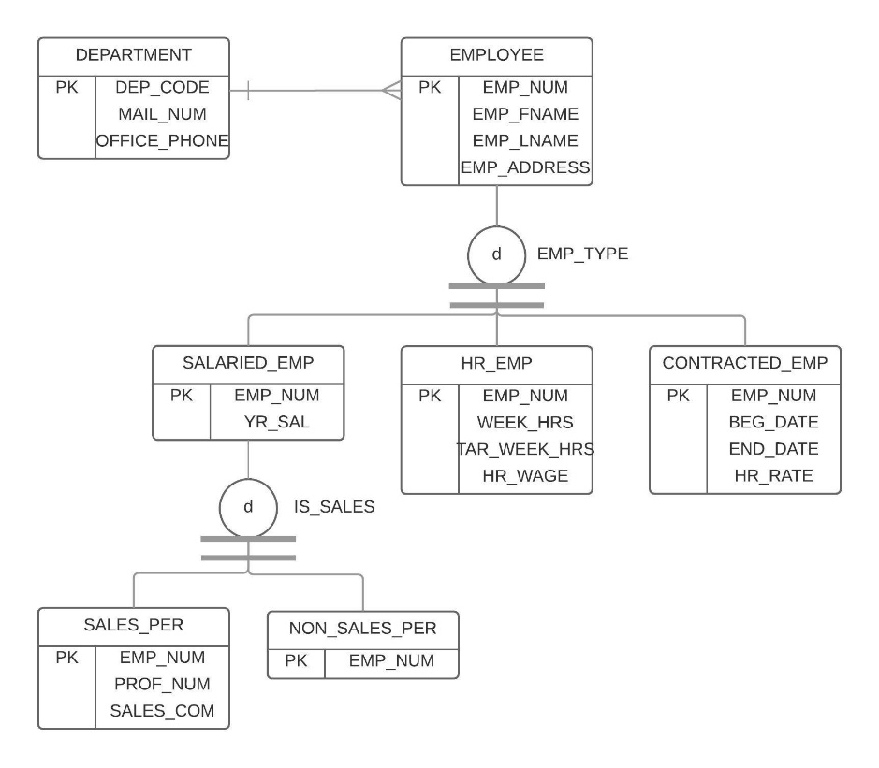

Q2)

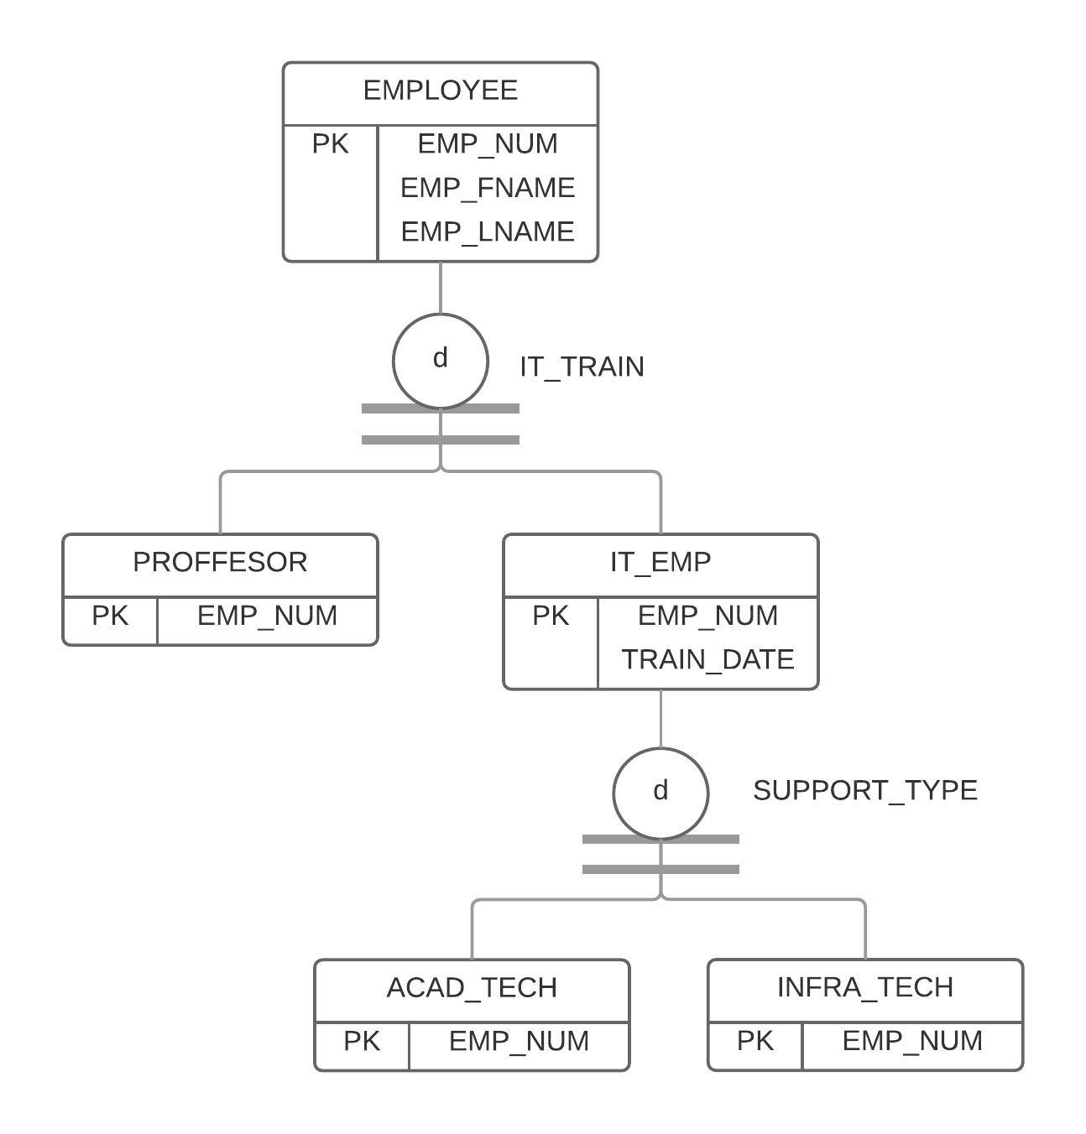

Q3a)

STUDENT (STU_NUM, STU_LNAME, STU_GPA, STU_HOURS, STU_CLASS, STU_MAJOR)

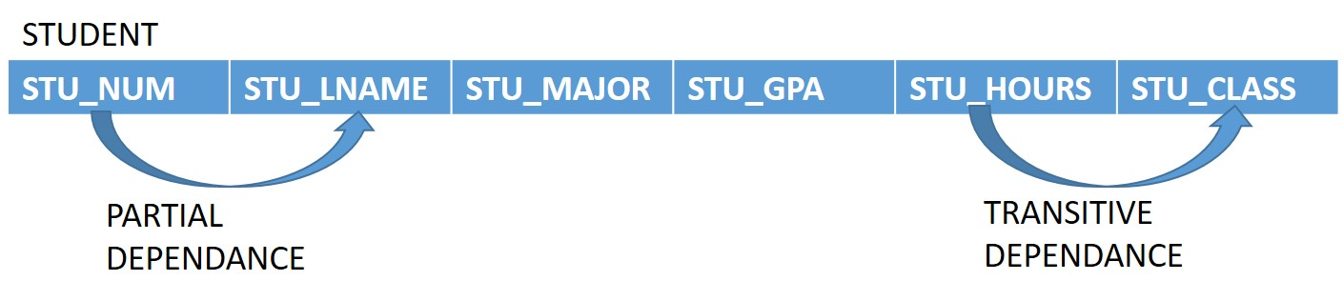

ADVISOR (ADVISOR_LNAME, ADVISOR_BLDG, ADVISOR_OFFICE, ADVISOR_PHONE)

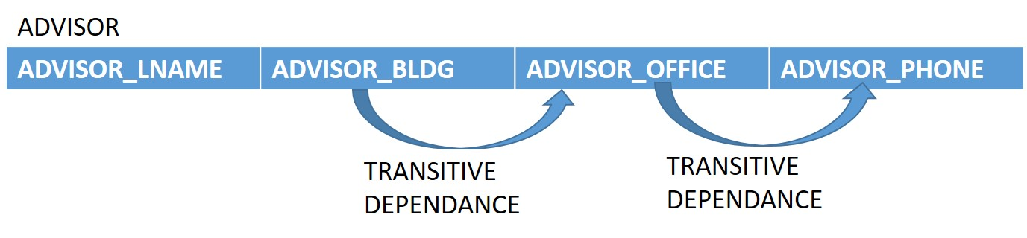

DEAPARTMENT (COLLEGE_NAME, DEPT_CODE, DEPT_NAME, DEPT_PHONE)

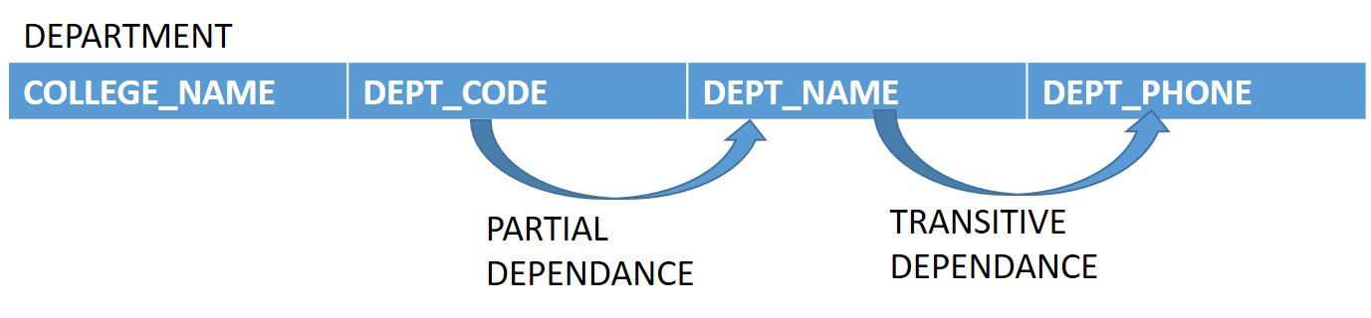

Q3b)

STUDENT (STU_NUM, STU_GPA, STU_HOURS, STU_MAJOR)

ADVISOR (ADVISOR_LNAME, ADVISOR_BLDG, ADVISOR_OFFICE)

DEPARTMENT (COLLEGE_NAME, DEPT_CODE)

Q3c)

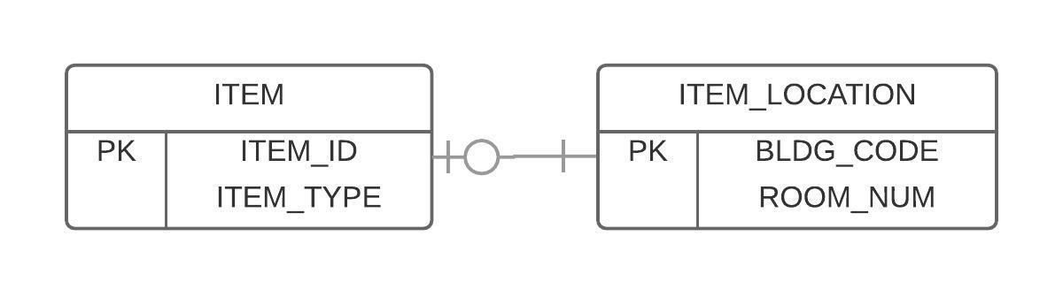

Q4a)

ITEM (ITEM_ID, ITEM_LABEL)

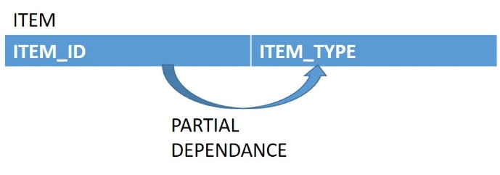

ROOM (ROOM_NUM)

BUILDING (BLDG_CODE, BLDG_NAME, BLDG_MANAGER)

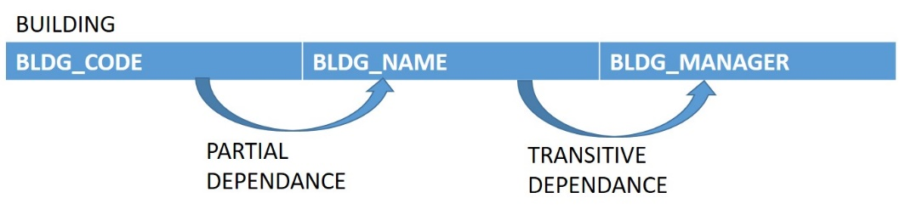

Q4b)

ITEM (ITEM_ID, ITEM_TYPE)

ITEM_LOCATION (BLDG_CODE, ROOM_NUM)

Q4c)

